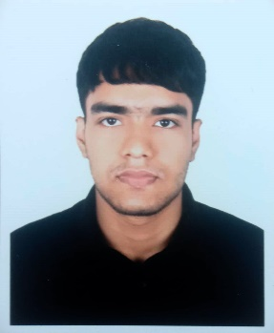
MUHAIMINUL RASHID SHAD
Contact Number: +880 1580355303
Email: mshad221487@bscse.uiu.ac.bd
GitHub: https://github.com/M-R-Saad
LinkedIn: https://www.linkedin.com/in/muhaiminul-rashid-shad-277562312/

ABOUT ME
Enthusiastic Computer Science and Engineering student with considerable proficiency in web development technologies. I am excited to learn about new technologies and frameworks. Pursuing possibilities for personal and intellectual development.

EDUCATIONAL QUALIFICATION

- 2022 – Present United International University
BSc. in Computer Science and Engineering
Current CGPA: 3.65 (8th Trimester)

- 2018 – 2020 Rajuk Uttara Model College
Higher Secondary Certificate
GPA: 5.00

- 2016 – 2018 Safiuddin Sarker Academy & College
Secondary School Certificate
GPA: 5.00

SKILLS

- Programming Languages: C, C++, Java, Python, PHP, JavaScript
- Database: MySQL, MongoDB
- Web Development: HTML, CSS, also familiar with React, Next.js
- Familiar Technologies:
  - GitHub
  - Figma
  - Adobe Illustrator
  - Basic Microsoft Office

LANGUAGES
- Bangla – Native
- English – Proficient

